Problem No: 01
Problem Statement:
Implement a program that performs Cyclic Redundancy Check (CRC) to detect errors in binary data transmission. The program should take a binary data string and a generator polynomial (divisor), append the necessary number of zeros to the data, and compute the CRC remainder using bitwise XOR operations. It should then form the transmitted message by appending the remainder to the original data. Finally, simulate the receiver's end to verify the integrity of the received message by recalculating the remainder. If the remainder is all zeros, output "Ok"; otherwise, output "Error" to indicate that data corruption has occurred.

Algorithm:

1. xor_Binary_Strings(A, B)
- Loop through the inputs bit by bit.
- Perform XOR between corresponding bits.
- Append each result to a new string.
- Return the final string.
2. crc_check(bin, divisor)
- Take an initial portion of the input.
- For each remaining bit:
◦ If a condition is met, apply XOR logic.
◦ Shift and include the next bit.
- After the loop, check if another XOR is needed.
- Return a sliced portion of the result.
3. receiver(bin, divisor)
- Use a helper to analyze the input.
- Check if any unexpected values are present.
- Based on findings, print a status message.
4. main()
- Prepare initial binary inputs.
- Extend one string based on another’s length.
- Use a helper to compute something.
- Adjust the result to match a required length.
- Combine strings and verify with another function.
- Conclude execution.

Flowchart:
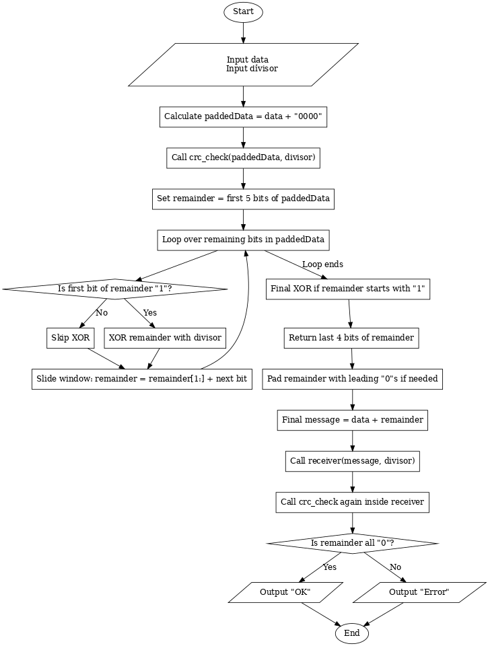

Codes:

#include <bits/stdc++.h>
using namespace std;

string xor_Binary_Strings(string &A, string &B) {
int len = A.length();
string result = "";

cout << "Performing XOR on " << A << " and " << B << ": ";

for (int i = 0; i < len; i++) {
char currentXOR = ((A[i] - '0') ^ (B[i] - '0')) + '0';
result += currentXOR;
}

cout << result << endl;
return result;
}

string crc_check(string bin, string divisor) {
cout << "\nStarting CRC check for binary string: " << bin << " with divisor: " << divisor << endl;

int divisorLen = divisor.length();
string remainder = bin.substr(0, divisorLen);

cout << "Initial remainder (first " << divisorLen << " bits): " << remainder << endl;

for (int i = divisorLen; i < bin.length(); i++) {
cout << "\nProcessing bit position " << i << " (bit value: " << bin[i] << ")" << endl;
cout << "Current remainder: " << remainder << endl;

if (remainder[0] == '1') {
cout << "First bit is 1, performing XOR with divisor." << endl;
remainder = xor_Binary_Strings(remainder, divisor);
cout << "Remainder after XOR: " << remainder << endl;
} else {
cout << "First bit is 0, no XOR performed." << endl;
}

string prevRem = remainder;
remainder = remainder.substr(1) + bin[i];
cout << "After shifting left and appending next bit: " << remainder
<< " (from " << prevRem << " shifted and + " << bin[i] << ")" << endl;
}

cout << "\nFinal step after processing all bits." << endl;
if (remainder.length() >= divisorLen && remainder[0] == '1') {
cout << "First bit of remainder is 1, performing final XOR with divisor." << endl;
remainder = xor_Binary_Strings(remainder, divisor);
cout << "Remainder after final XOR: " << remainder << endl;
}

cout << "Final remainder before truncation: " << remainder << endl;
string result = remainder.substr(1);
cout << "Truncated remainder (excluding first bit): " << result << endl;

return result;
}

void receiver(string bin, string divisor) {
cout << "\nReceiver's CRC check on received message: " << bin << endl;
string c = crc_check(bin, divisor);

cout << "Remainder after CRC check: " << c << endl;

bool found = false;
for (auto p : c) {
if (p != '0') {
found = true;
break;
}
}

if (found) {
cout << "Error detected in the received message." << endl;
} else {
cout << "No errors detected. Received message is correct." << endl;
}
}

int main() {
string data, divisor;
cout << "Enter Data: ";
cin >> data;
cout << "Enter Divisor: ";
cin >> divisor;

int divisorLen = divisor.length();
cout << "\nPadding data with " << (divisorLen - 1) << " zeros." << endl;
string paddedData = data + string(divisorLen - 1, '0');
cout << "Padded data: " << paddedData << endl;

cout << "\nComputing CRC remainder..." << endl;
string remainder = crc_check(paddedData, divisor);
cout << "\nRaw remainder from CRC computation: " << remainder << endl;

cout << "Adjusting remainder to " << (divisorLen - 1) << " bits." << endl;
while (remainder.length() < divisorLen - 1) {
remainder = "0" + remainder;
}
cout << "Adjusted remainder: " << remainder << endl;

string transmitted = data + remainder;
cout << "\nTransmitted message (data + remainder): " << transmitted << endl;

receiver(transmitted, divisor);
return 0;
}

Output:

